Christos Parginos
Chair Socio-Cultural Commission

chair-SCC@ieb-ipa.org

All Sections
Ioannina,18 February 2026

INTERNATIONAL PHOTOGRAPHY COMPETITION 2026
Organised by the Socio-Cultural Commission of the IPA
Arts and Culture Project

AWARD CATEGORIES:

Open Category
a) Any photographic subject or topic

INTERNATIONAL

POLICE

ASSOCIATION

–

INTERNTIONAL

EXECUTIVE

BOARD

NGO in
Consultative (Special) Status with the Economic and Social Council of the United Nations;

in

Consultative

Status

with the

Organization

of

American

States

and

UNESCO

1

Subject Category
b) Police at work, emphasising in Women in police

A prize of 400 Euros will be awarded to the overall winner.
300 Euros will be awarded to the winner of each category, with second and third places also receiving awards of 200 and 100 Euros respectively.
Further, 6 (six) more photos will receive a merit award.

JUDGES: Professional photographers

TIMEFRAME: Deadline for Entries: 31 July 2026
Selection: 15 August 2026

A first display of the photos will take place during the IPA World Congress 2026 in Sri Lanka. A total of 50 images will be selected and will be sent to IPA Section Sri Lanka for mounting and displaying at the International Exhibition. Subsequently the photographs will be offered to other sections, to encourage them to hold similar exhibitions.

RULES:

- The competition is open to all members of the International Police Association.

- Entries are limited to 5 photographs per person for each category.

- Prizes will be awarded as stated and will be presented at the IPA World Congress 2026 in Sri Lanka.
- All photographs should be sent together with the official entry form by email to the following email address: anetasobieraj@ipapolska.pl
- Aneta Sobieraj will be the contact person (Arts and Culture Project Member)
If the size of the photographs exceeds 10 MB, please send several emails.


- Copyright: The right to reproduce photographic images for International Police Association purposes is assumed.
INTERNATIONAL

POLICE

ASSOCIATION

–

INTERNATIONAL

EXECUTIVE

BOARD

NGO in Consultative (Special) Status with the Economic and Social Council of the United Nations;

in

Consultative

Status

with the

Organization

of

American

States

and

UNESCO

2

- The judges’ decision is final, and no correspondence will be entered into by the International Police Association.

- Whilst the International Police Association will exercise care in the handling of entries, it regrets that it cannot accept any responsibility for the loss of images, however caused.
- • Submission of entries implies acceptance of the stated Rules.

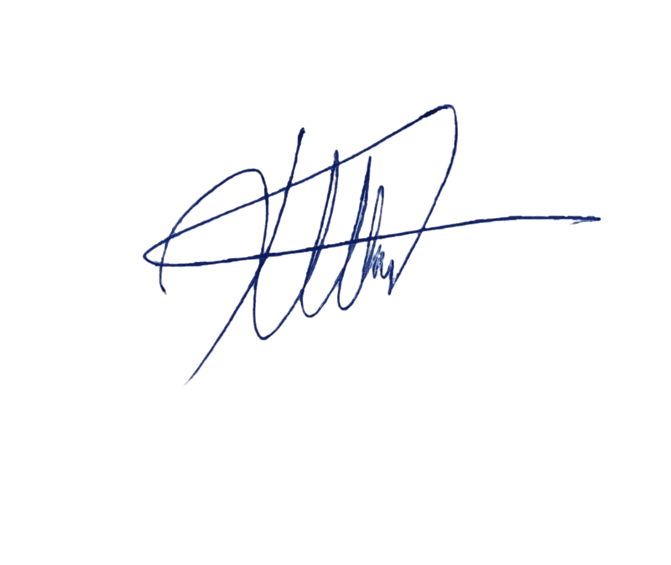
Christos Parginos

Chair Socio-cultural commission

